8
18
roduction

THE MARKETS FOR THE FACTORS OF PRODUCTION

WHAT’S NEW IN THE SEVENTH EDITION:

The tables and values have been updated to the most recently available numbers. The In The News feature on "The Economics of Immigration" has been updated.

LEARNING OBJECTIVES:

By the end of this chapter, students should understand:

➢ the labor demand of competitive, profit-maximizing firms.

➢ the household decisions that lie behind labor supply.

➢ why equilibrium wages equal the value of the marginal product of labor.

➢ how the other factors of production—land and capital—are compensated.

➢ how a change in the supply of one factor alters the earnings of all of the factors.

CONTEXT AND PURPOSE:

Chapter 18 is the first chapter in a three-chapter sequence that addresses the economics of labor markets. Chapter 18 develops and analyzes the markets for the factors of production—labor, land, and capital. Chapter 19 builds on Chapter 18 and explains in more detail why some workers earn more than others do. Chapter 20 addresses the distribution of income and the role the government can play in altering the distribution of income.
The purpose of Chapter 18 is to provide the basic theory for the analysis of factor markets—the markets for labor, land, and capital. As you might expect, we find that the wages earned by the factors of production depend on the supply and demand for the factor. What is new in the analysis is that the demand for a factor is a derived demand. That is, a firm’s demand for a factor is determined by its decision to supply a good in another market.

KEY POINTS:

• The economy’s income is distributed in the markets for the factors of production. The three most important factors of production are labor, land, and capital.

• The demand for factors, such as labor, is a derived demand that comes from firms that use the factors to produce goods and services. Competitive, profit-maximizing firms hire each factor up to the point at which the value of the factor's marginal product equals its price.

• The supply of labor arises from individuals’ trade-offs between work and leisure. An upward-sloping labor supply curve means that people respond to an increase in the wage by working more hours and enjoying less leisure.

• The price paid to each factor adjusts to balance the supply and demand for that factor. Because factor demand reflects the value of the marginal product of that factor, in equilibrium each factor is compensated according to its marginal contribution to the production of goods and services.

• Because factors of production are used together, the marginal product of any one factor depends on the quantities of all factors that are available. As a result, a change in the supply of one factor alters the equilibrium earnings of all the factors.

CHAPTER OUTLINE:


Begin this chapter by reviewing how demand and supply determine product prices. Start by asking, “Why is chicken cheaper than steak?” and “Why are apples cheaper (per pound) than grapes?” Review the explanations using supply and demand analysis. Now ask, “Why do airline pilots earn more than school bus drivers?” and “Why is land on the Boardwalk in Atlantic City more expensive than land 50 miles southwest of Atlantic City?”

I. Definition of factors of production: the inputs used to produce goods and services.

A. The markets for these factors of production are similar to the markets for goods and services discussed earlier, but they are different in one important way.

B. The demand for a factor of production is a derived demand, meaning that the firm's demand for a factor of production is derived from its decision to supply a good in another market.

II. The Demand for Labor
In the market for labor, households are the suppliers while firms are the demanders. You will need to remind students of this because they are used to seeing markets in which this is reversed.

A. The wage earned by workers is determined by the supply and demand for workers.
Figure 1

B. The Competitive Profit-Maximizing Firm

1. Example: A firm that owns an orchard must decide how many apple pickers to hire.

2. Assume that the firm operates in both a competitive output market and a competitive labor market.

a. This implies that the firm is a price taker in the apple market, meaning that it has no control over the price at which it can sell its apples.

b. The firm is also a price taker in the labor market, meaning that it has no control over the wage that it must pay its apple pickers.

3. Assume also that the firm's goal is to maximize profit (total revenue – total cost).

C. The Production Function and the Marginal Product of Labor

1. The firm must consider how the quantity of apples it can harvest and sell is affected by the number of apple pickers hired.

2. Definition of production function: the relationship between the quantity of inputs used to make a good and the quantity of output of that good.

3. Definition of marginal product of labor: the increase in the amount of output from an additional unit of labor.
Table 1

L | Q | MPL | VMPL  (= P x MPL) | W | Marginal Profit
0 | 0 | ---- | ---- | ---- | ----
1 | 100 | 100 | $1,000 | $500 | $500
2 | 180 | 80 | 800 | 500 | 300
3 | 240 | 60 | 600 | 500 | 100
4 | 280 | 40 | 400 | 500 | –100
5 | 300 | 20 | 200 | 500 | –300

4. Definition of diminishing marginal product: the property whereby the marginal product of an input declines as the quantity of the input increases.
Figure 2

D. The Value of the Marginal Product and the Demand for Labor

1. When deciding how many workers to hire, the firm considers how much profit each worker would bring in.

2. Because profit equals total revenue minus total cost, the profit from an additional worker is the worker's contribution to revenue minus the worker's wage.

3. Definition of value of the marginal product: the marginal product of an input times the price of the output.



a. Economists sometimes refer to the value of the marginal product as the firm’s marginal revenue product.

b. The value of the marginal product is the extra revenue a firm gets from hiring an additional unit of a factor of production.
ALTERNATIVE CLASSROOM EXAMPLE:

Binkle, Inc. produces and sells plastic bottles in a perfectly competitive market at a price of $0.25. Binkle hires its labor in a perfectly competitive labor market at an hourly wage of $10. The relationship between the quantity of labor hired and the amount of output produced per hour is presented in the following table:

L | Q | MPL | VMPL  (= P x MPL) | W | Marginal Profit
0 | 0 | ---- | ---- | ---- | ----
1 | 90 | 90 | $22.5 | $10 | $12.5
2 | 170 | 80 | 20 | 10 | 10
3 | 240 | 70 | 17.5 | 10 | 7.5
4 | 300 | 60 | 15 | 10 | 5
5 | 350 | 50 | 12.5 | 10 | 2.5
6 | 390 | 40 | 10 | 10 | 0
7 | 420 | 30 | 7.5 | 10 | –2.5
8 | 440 | 20 | 5 | 10 | –5

4. If the wage for workers is $500 per week, the firm will only hire three workers.

a. For the first three workers, the value of the marginal product is greater than the wage, so the marginal profit from hiring these workers is positive.

b. For the fourth worker, the value of the marginal product is lower than the wage, so the marginal profit from hiring this worker would be negative.

5. We can show the firm's decision graphically.

a. The value of the marginal product curve will slope downward because of the diminishing marginal product of labor.

b. The wage is depicted by a horizontal line because the firm is a price taker in the labor market.

6. A competitive, profit-maximizing firm hires workers up to the point at which the value of the marginal product of labor equals the wage.

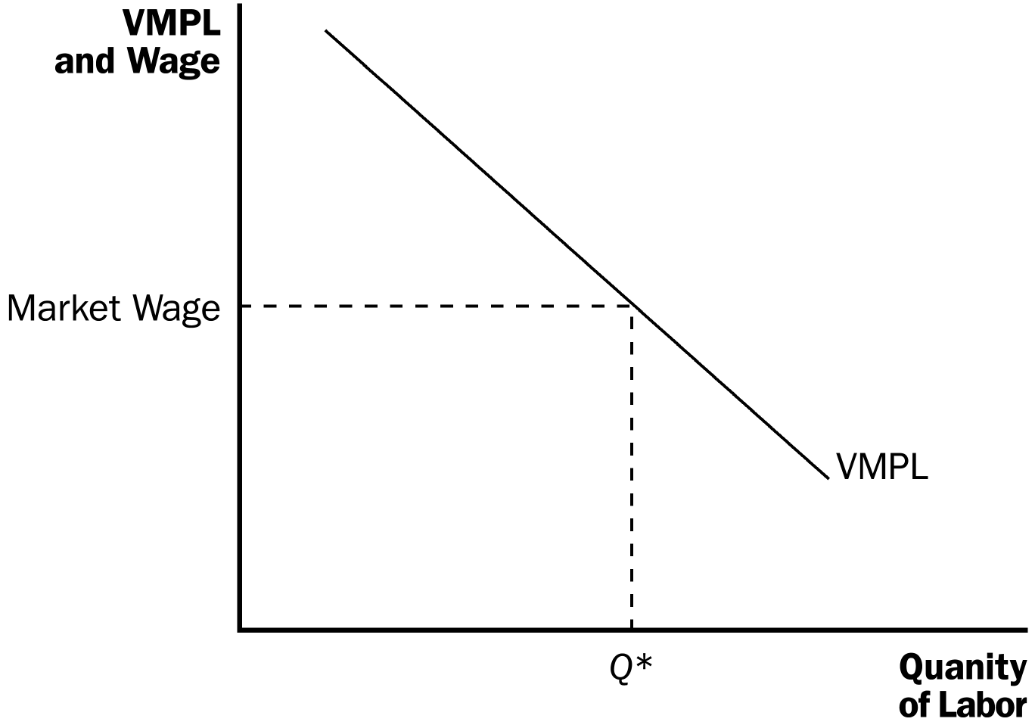
Figure 3

7. Because the firm chooses the quantity of labor at which the value of the marginal product equals the wage, the value-of-the-marginal-product curve is the firm's labor demand curve.

Emphasize that because the value of the marginal product involves both the marginal product and the price of the good, any change in either of these two determinants will lead to a change in the demand for labor.

E. FYI: Input Demand and Output Supply: Two Sides of the Same Coin

1. If W is the wage and an extra unit of labor produces MPL units of output, then the marginal cost of a unit of output is MC = W/MPL.

2. A profit-maximizing firm chooses the quantity of labor so that the value of the marginal product (P x MPL) is equal to the wage (W):

P x MPL = W.

Divide both sides by MPL to get:

P = W/MPL.

Because W/MPL = MC, we have:

P = MC.

Students will probably not appreciate how important this is. For that reason, make sure that you go through it slowly.

3. When a competitive firm hires labor up to the point at which the value of the marginal product is equal to the wage, it also produces a level of output at which price equals marginal cost.

F. What Causes the Labor Demand Curve to Shift?

1. The Output Price

a. An increase in the price of the product raises the value of the marginal product of labor and therefore increases the demand for labor.

b. A decrease in the price of the product lowers the value of the marginal product of labor and therefore decreases the demand for labor.

2. Technological Change

a. Technological advance raises the marginal product of labor, which in turn raises the value of the marginal product of labor.

b. It is also possible for technological change to reduce labor demand. A labor-saving technological change (such as an industrial robot) could reduce the marginal product of labor and thus the value of the marginal product of labor.

c. History suggests that most technological progress has been labor augmenting.

3. The Supply of Other Factors

a. The quantity available of one factor can affect the marginal product of another.

b. Therefore, any change in the availability of another factor will likely affect the demand for labor.

III. The Supply of Labor

A. The Trade-off between Work and Leisure

1. Any hours spent working are hours that could be devoted to something else like studying or watching television. Economists refer to all time not spent working for pay as “leisure.”

2. The opportunity cost of an hour of leisure is the amount of money that would have been earned if that hour were spent at work.

3. Therefore, as the wage increases, so does the opportunity cost of leisure.

4. The labor supply curve shows how individuals respond to changes in the wage in terms of the labor–leisure trade-off.

a. An upward-sloping labor supply curve means that an increase in the wage induces workers to increase the quantity of labor they supply.

b. Note that, for some individuals, the labor supply curve may in fact be backward bending. This possibility is discussed in more detail in Chapter 21.

B. What Causes the Labor Supply Curve to Shift?

1. Changes in Tastes (for leisure vs. working)

2. Changes in Alternative Opportunities (other occupations)

3. Immigration

IV. Equilibrium in the Labor Market
Figure 4

A. Marginal Product in Equilibrium

1. The wage adjusts to balance the quantity of labor supplied and the quantity of labor demanded.

2. The wage equals the value of the marginal product of labor.

3. At the labor market equilibrium, each firm has bought as much labor as it finds profitable at the equilibrium wage.

4. Thus, any event that changes the supply or demand for labor must change the equilibrium wage and the value of the marginal product by the same amount, because these must always be equal.
Go through each of these shifts carefully with the class. Make sure that they see the relationship between the change in the equilibrium wage and the change in the value of the marginal product of labor.

B. Shifts in Labor Supply
Figure 5

1. An increase in the supply of labor would shift the supply curve to the right, creating a surplus of workers at the original wage. This will put downward pressure on the equilibrium wage, causing the quantity of labor demanded to rise.

a. As the number of workers employed rises, the marginal product of labor falls due to the diminishing marginal product of labor.

b. Thus, both the wage and the value of the marginal product of labor are now lower.

2. A decrease in the supply of labor would shift the supply curve to the left, creating a shortage of workers at the original wage. This will put upward pressure on the equilibrium wage, causing the quantity of labor demanded to fall.

a. As the number of workers employed falls, the marginal product of labor rises due to the diminishing marginal product of labor.

b. Thus, both the wage and the value of the marginal product of labor are now higher.

3. In the News: The Economics of Immigration

a. Increased immigration leads to a rise in the supply of labor.

b. This is an interview with economist Pia Orrenius, an economist at the Federal Reserve Bank of Dallas, who studies the economic impact of increased immigration.

C. Shifts in Labor Demand
Figure 6

1. An increase in the demand for labor will shift the labor demand curve to the right, creating a shortage at the original wage. This will put upward pressure on the equilibrium wage causing the quantity of labor supplied to increase.

a. The value of the marginal product rises because VMPL = P × MPL (and either P or MPL have risen to cause the demand for labor to rise).

b. This implies that both the wage and the value of the marginal product are now higher.

2. A decrease in the demand for labor will shift the labor demand curve to the left, creating a surplus at the original wage. This will put downward pressure on the equilibrium wage causing the quantity of labor supplied to decrease.

a. The value of the marginal product falls because VMPL = P × MPL (and either P or MPL have fallen to cause the demand for labor to decline).

b. This implies that both the wage and the value of the marginal product are now lower.

D. Case Study: Productivity and Wages

1. Principle #7: Our standard of living depends on our ability to produce goods and services.

2. This means that highly productive workers are highly paid, and less productive workers are less highly paid.

3. Table 2 shows data on the growth rates of both productivity and wages in the United States from 1959 to 2012.

Table 2

a. From 1959 to 2012, productivity grew by about 2.1% per year.
b. From 1973 to 1995, the growth in productivity was slow compared to the period before 1973 or the period since 1995.

E. FYI: Monopsony

1. Example: the labor market in a small town dominated by a single large employer.

2. This type of labor market is called a monopsony.

3. A monopsony firm hires fewer workers than a competitive labor market and pays a lower wage.
Compare the difference in outcomes between perfect competition and monopoly in output markets with the differences between perfect competition and monopsony in labor markets.

V. The Other Factors of Production: Land and Capital

A. Definition of capital: the equipment and structures used to produce goods and services.

B. Equilibrium in the Markets for Land and Capital
Figure 7

1. The purchase price of land or capital is the price paid to own that factor of production indefinitely.

2. The rental price of land or capital is the price paid to use that factor for a limited amount of time.

3. Because the wage is simply the rental price of labor, what we know about wage determination also applies to the rental prices of land and capital.

a. The rental price of land is determined by the supply and demand for land; the rental price of capital is determined by the supply and demand for capital.

b. For both land and capital, the firm increases the quantity hired until the value of the factor's marginal product equals the factor's rental price.

4. As long as the firms using the factors of production are competitive and profit maximizing, land, labor, and capital each earn the value of their marginal contribution to the production process.

5. The purchase price of land and capital depend on the current value of the marginal product and the expected future value of the marginal product.

C. FYI: What Is Capital Income?

1. The measurement of capital income is less obvious than the measurement of labor income.

2. Capital income is the rent that households receive for the use of their capital.

3. Some of the earnings from capital are paid to households in the form of interest or dividends.

4. Also, some of the earnings from capital may be retained by the firm for future purchases of capital.

D. Linkages among the Factors of Production

1. In most situations, factors of production are used together in a way that makes the productivity of each factor dependent on the quantities of the other factors available to be used in the production process.

2. This means that a change in the supply of any one factor can change the earnings of all of the factors.

3. The change in the earnings of any factor can be found by measuring the impact of the event on the value of the marginal product of that factor.

4. Case Study: The Economics of the Black Death

a. In 14th-century Europe, the bubonic plague killed about one-third of the population within a few years.

b. With a smaller supply of workers, we would expect that the wages paid to workers would rise. This occurs because of diminishing marginal returns: As the number of workers employed falls, the marginal product of labor rises. Thus, the value of the marginal product of labor rises.

c. With fewer workers available to work the land, each additional unit of land was able to produce less additional output. Thus, the marginal product of land fell. Because this would lead to a decrease in the value of the marginal product of land as well, we would expect the rental price on land to fall.

d. History shows that our predictions are correct: Wages doubled during the period and rents declined by 50%.

SOLUTIONS TO TEXT PROBLEMS:

Quick Quizzes

1. The marginal product of labor is the increase in the amount of output from an additional unit of labor. The value of the marginal product of labor is the marginal product of labor times the price of the output.

A competitive, profit-maximizing firm decides how many workers to hire by hiring workers up to the point where the value of the marginal product of labor equals the wage.

2. A brain surgeon has a higher opportunity cost of enjoying leisure than a janitor because the surgeon’s wage is much higher. Doctors work such long hours because leisure is very expensive for them.

3. An immigration of workers increases labor supply but has no effect on labor demand. The result is an increase in the equilibrium quantity of labor and a decline in the equilibrium wage, as shown in Figure 1. The decline in the equilibrium wage causes the quantity of labor demanded to increase. The increase in the equilibrium quantity of labor causes the marginal product of labor to decrease.

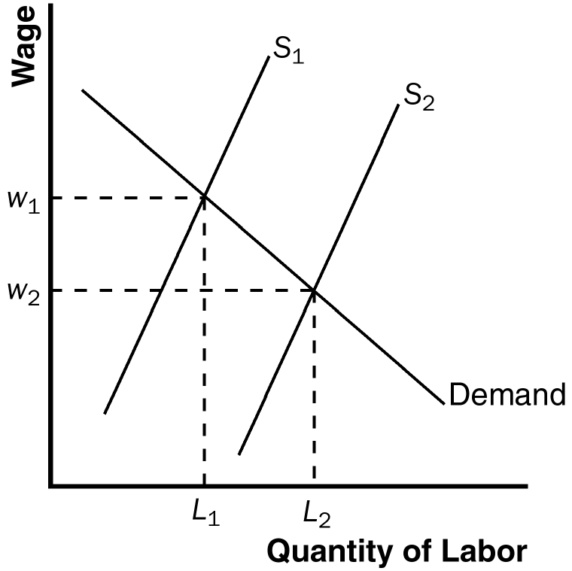

Figure 1

4. The income of the owners of land and capital is determined by the value of the marginal contribution of land and capital to the production process.

An increase in the quantity of capital would reduce the marginal product of capital, thus reducing the incomes of those who already own capital. However, it would increase the incomes of workers because a higher capital stock raises the marginal product of labor.

Questions for Review

1. A firm's production function describes the relationship between the quantity of labor used in production and the quantity of output from production. The marginal product of labor is the increase in the amount of output from an additional unit of labor. Thus, the marginal product of labor depends directly on the production function. The value of the marginal product of labor is the marginal product of labor multiplied by the market price of the output.

A competitive, profit-maximizing firm hires workers up to the point where the value of the marginal product of labor equals the wage. As a result, the value-of-marginal-product curve is the firm’s labor-demand curve.

2. Events that could shift the demand for labor include changes in the output price, technological change, and changes in the supply of other factors. If the output price increases, the firm's labor-demand curve will shift to the right because the value of the marginal product of labor increases. Technological advances typically raise the marginal product of labor, which in turn increases the demand for labor and shifts the labor-demand curve to the right. If the supply of capital increases, the marginal product of labor increases and the labor-demand curve shifts to the right.

3. Events that could shift the supply of labor include changes in tastes, changes in alternative opportunities, and immigration. If more people choose to work, the supply of labor will increase. If the wage earned in one labor market rises relative to the wage earned in another labor market, the supply of labor in the higher-wage market will increase. When immigrants enter a country, the supply of labor in that country increases.

4. The wage can adjust to balance the supply and demand for labor while simultaneously equaling the value of the marginal product of labor. Supply and demand for labor determine the equilibrium wage. Firms maximize profits by choosing the amount of labor where the wage is equal to the value of the marginal product of labor.

5. A large wave of immigration would increase the supply of labor, thus reducing the wage. With more labor working with capital and land, the marginal product of capital and land is higher, so rents earned by owners of land and capital would increase.

Quick Check Multiple Choice
1. c
2. b

3. a
4. b
5. d
6. d

Problems and Applications

1. a. The law requiring people to eat one apple a day increases the demand for apples. As shown in Figure 2, demand shifts from D₁ to D₂, increasing the price from P₁ to P₂, and increasing quantity from Q₁ to Q₂.

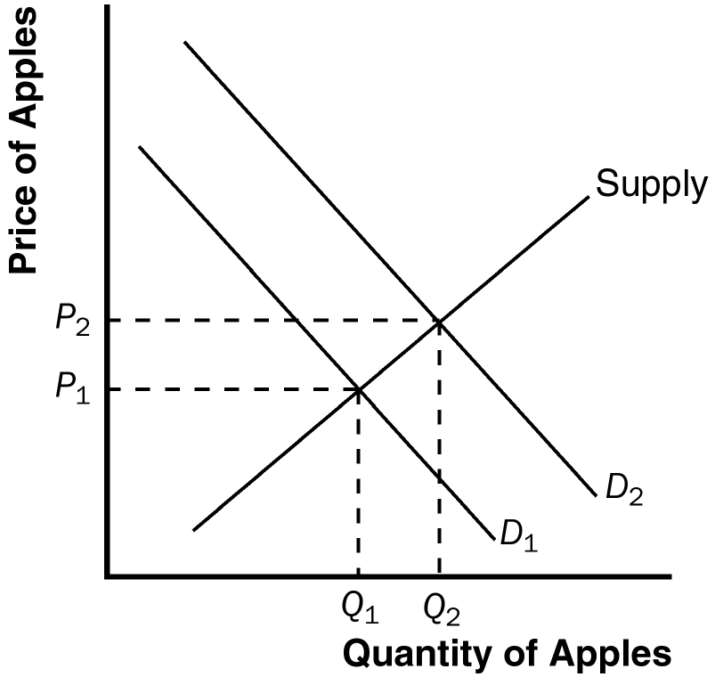

Figure 2

b. Because the price of apples increases, the value of the marginal product increases for any given quantity of labor. There is no change in the marginal product of labor for any given quantity of labor. However, firms will choose to hire more workers and thus the marginal product of labor at the profit-maximizing level of labor will be lower.

c. As Figure 3 shows, the increase in the value of the marginal product of labor shifts the demand curve of labor from D₁ to D₂. The equilibrium quantity of labor rises from L₁ to L₂, and the wage rises from w₁ to w₂.

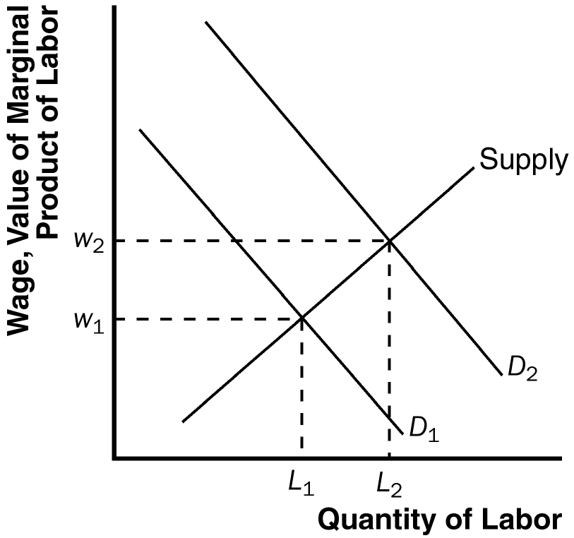

Figure 3

2. a. If Congress were to buy personal computers for all U.S. college students, the demand for computers would increase, raising the price of computers and thus increasing the value of the marginal product of workers who produce computers. This is shown in Figure 4 as a shift in the demand curve for labor from D₁ to D₂. The result is an increase in the wage from w₁ to w₂ and an increase in the quantity of labor from L₁ to L₂.

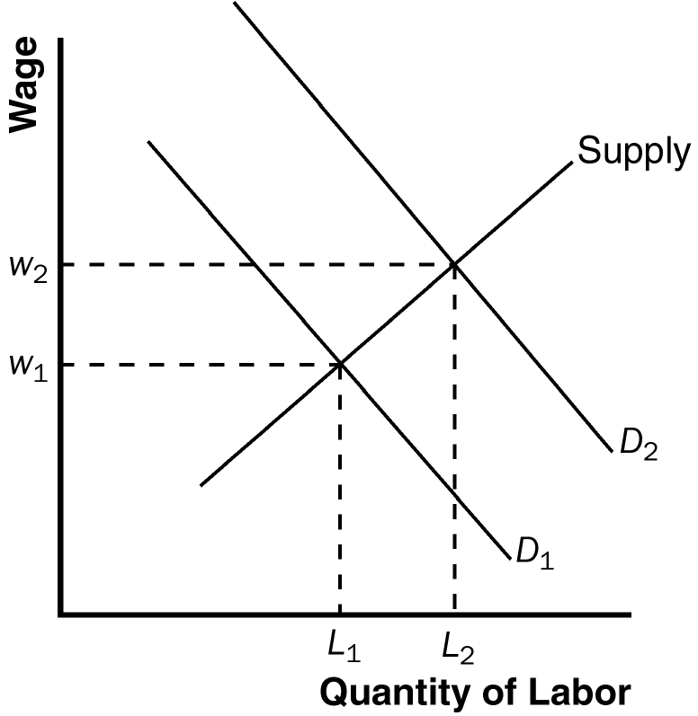

Figure 4

b. If more college students major in engineering and computer science and assuming this trend does not affect the demand for computers, the supply of labor in the computer industry rises. This is shown in Figure 5 as a shift in the supply curve from S₁ to S₂. The result is a decrease in the wage from w₁ to w₂ and an increase in the quantity of labor from L₁ to L₂.

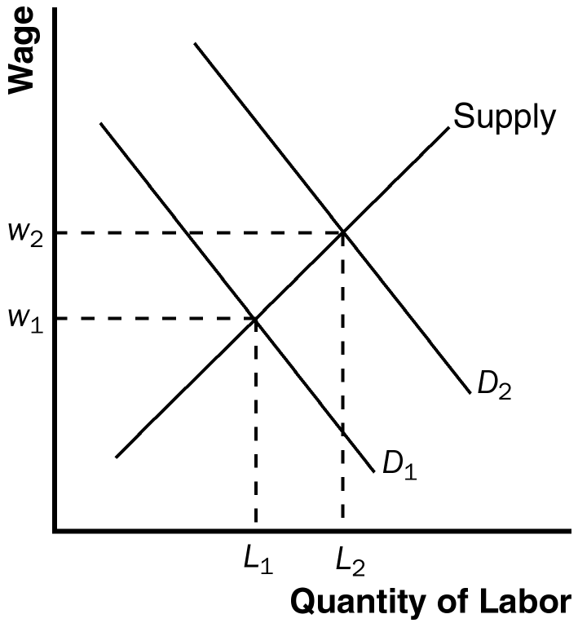

Figure 5 Figure 6

c. If computer firms build new manufacturing plants, this increases the marginal product of labor and the value of the marginal product of labor for any given quantity of labor. This is shown in Figure 6 as a shift in the demand curve for labor from D₁ to D₂. The result is an increase in the wage from w₁ to w₂ and an increase in the quantity of labor from L₁ to L₂.

3. a. The marginal product of labor is equal to the additional output produced by an additional unit of labor. The table below shows the marginal product of labor (MPL) for this firm:

Days of Labor | Units of Output | MPL | VMPL
0 | 0 | -- | --
1 | 7 | 7 | 70
2 | 13 | 6 | 60
3 | 19 | 6 | 60
4 | 25 | 6 | 60
5 | 28 | 3 | 30
6 | 29 | 1 | 10
7 | 29 | 0 | 0

b. The value of the marginal product of labor (VMPL) is equal to the price of the output ($10) multiplied by the marginal product of labor (MPL). It is also reported in the table.

c. The labor demand schedule for the firm is:

Wage | Quantity of Labor Demanded
$0 | 7
10 | 6
30 | 5
60 | 4
60 | 3
60 | 2
70 | 1

d. The labor demand curve is the same as the value-of-the-marginal-product curve. It is shown in Figure 7.

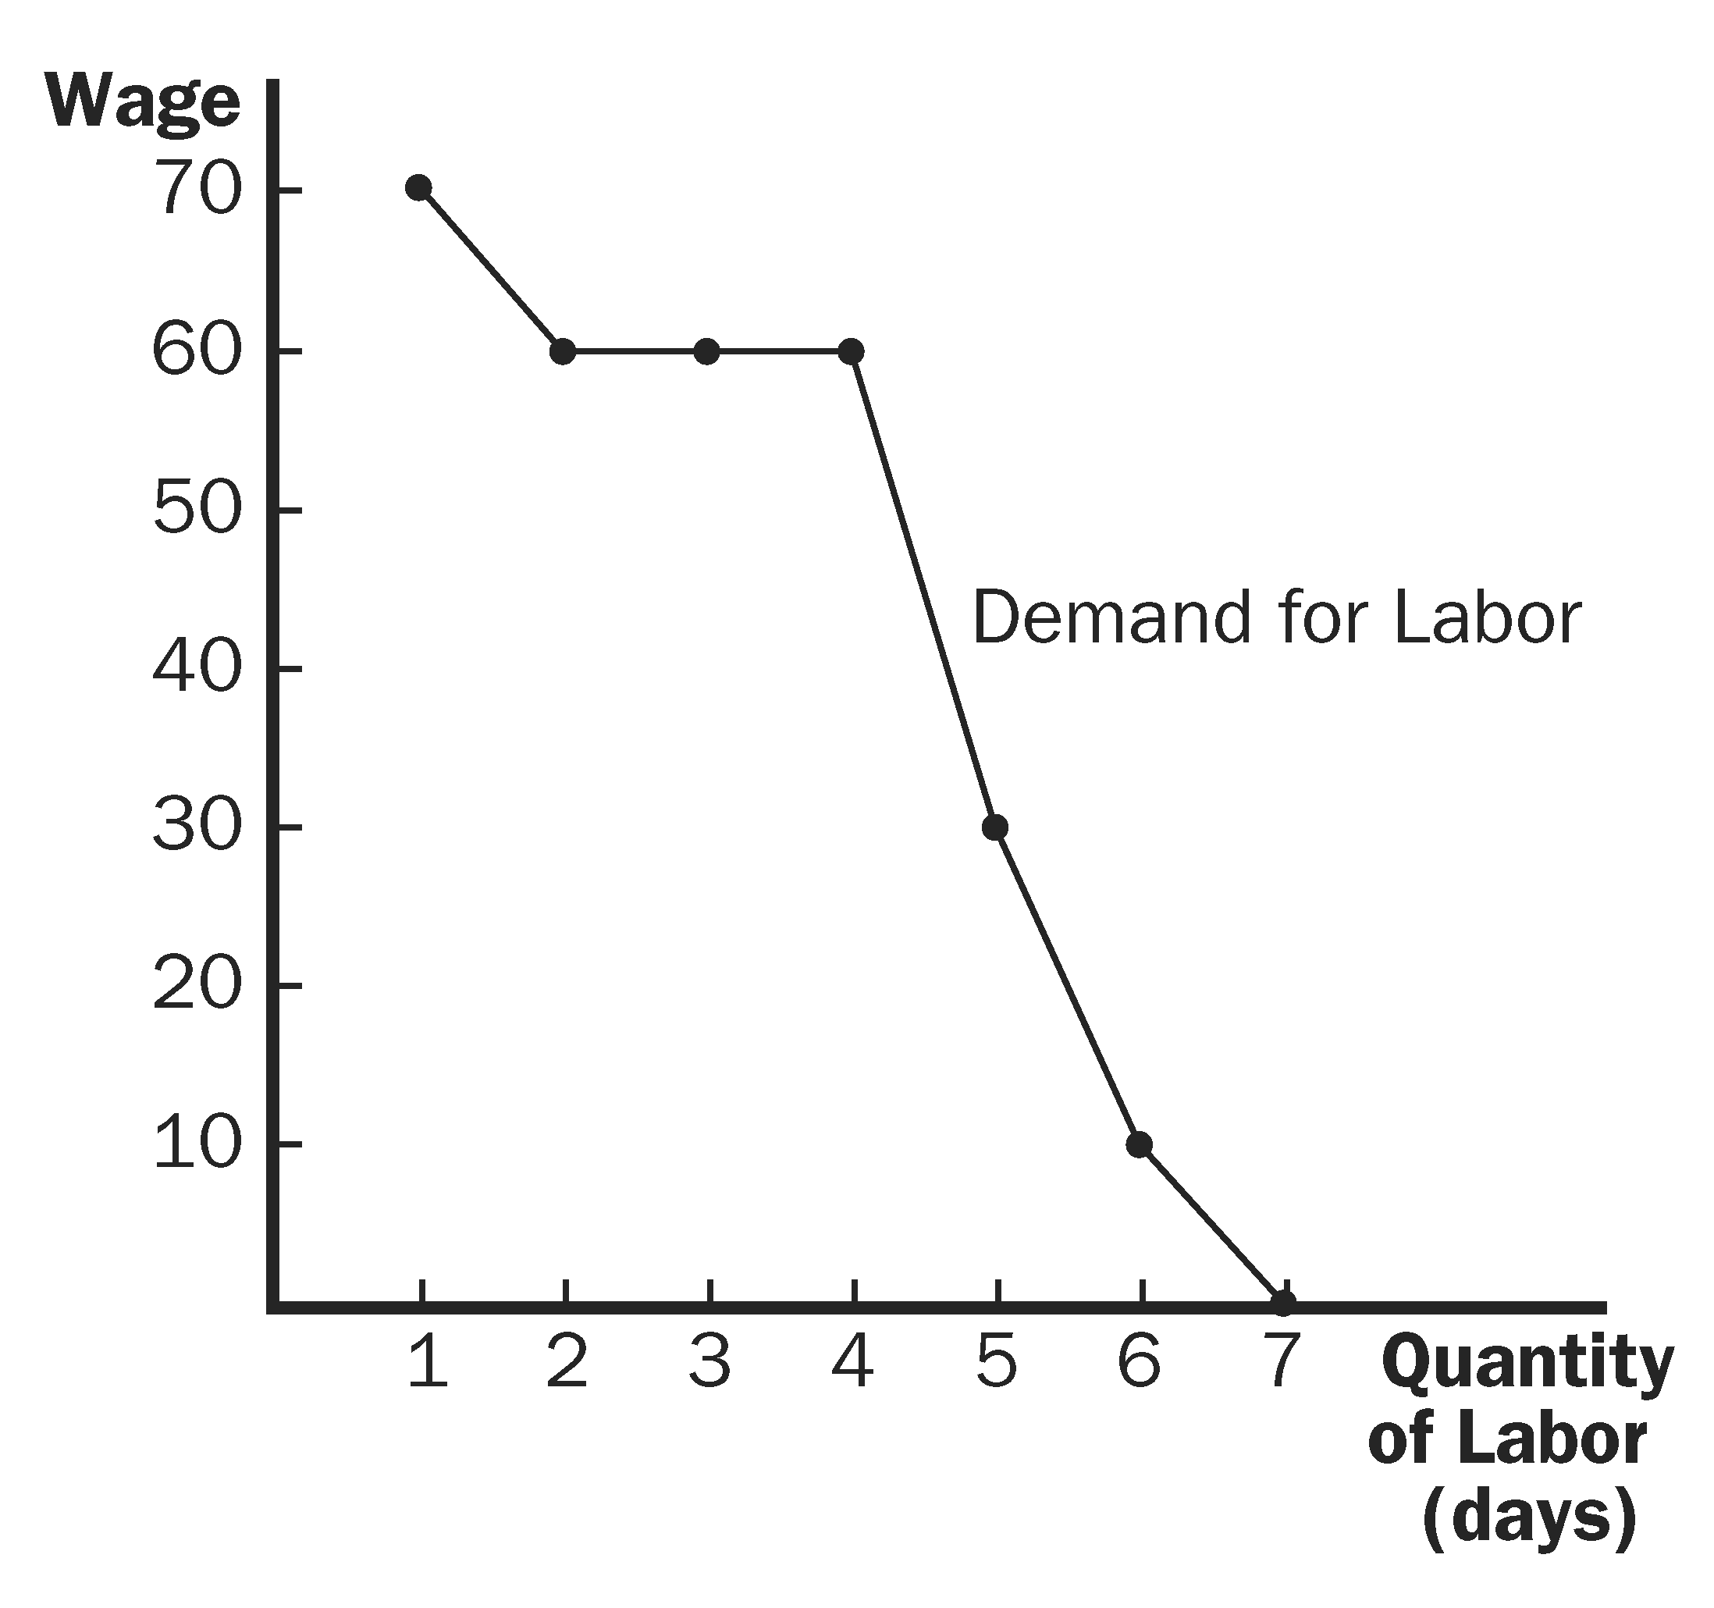
Figure 7

e. If the price of the output rises to $12, the demand for labor will shift to the right because the value of the marginal product will be higher at each level of labor hired.

4. a. Because the firm can sell all of the milk it wants to at the market price of $4 per gallon, Smiling Cow Dairy operates in a perfectly competitive output market.

b. Because the firm can rent all the robots it wants to at the market price of $100 per day, Smiling Cow Dairy rents robots in a perfectly competitive market.

c. The table below shows the MP and VMP for robots:
# Robots | Total Output | MP | VMP
0 | 0 gallons | ---- | ----
1 | 50 | 50 gallons | $ 200
2 | 85 | 35 | 140
3 | 115 | 30 | 120
4 | 140 | 25 | 100
5 | 150 | 10 | 40
6 | 155 | 5 | 20

d. The firm should rent robots up to the point where VMP is equal to the wage. Therefore, it should rent 4 robots.

5. a. The firm’s demand for labor is the same as its value of the marginal product. The firm will set wage equal to VMP:

w = VMP = P × MP_{L} = 2(100 – 2L) = 200 – 4L

The market demand curve for labor will be the horizontal summation of the 20 firm demand curves (summed across L).

Rearranging the firm’s demand, we get L = 50 – 0.25w. Thus, the market demand curve must be L = 20(50 – 0.25w) = 1,000 – 5w.

b. If labor supply is inelastic at 200, then we can solve for wage by determining the market equilibrium:

200 = 1,000 – 5w
w = 160.

Each firm will hire 10 workers (200 workers/20 orchards) and produce Q = 100(10) – (10)² = 900 apples. Total revenue for each firm will be (2)(900) = 1,800. Assuming that wages are the firm’s only costs, total costs will be (160)(10) = 1,600, leaving each firm with profit = 200. Total income for the country will be (200)(160) + (20)(200) = 36,000.

c. If the world price of apples rises to $4, the value of the marginal product (and thus each firm’s demand for labor) rises.
w = VMP = P × MP_{L} = 4(100 – 2L) = 400 – 8L
Rearranging for L, we get L = 50 – 0.125w. Thus, the market demand for labor becomes:
L = 20(50 – 0.125w) = 1,000 – 2.5w. Finding the new equilibrium wage, we get:
200 = 1,000 – 2.5w
w = 320
Each firm will still hire 10 workers and produce 900 apples. Thus total revenue will be (4)(900) = 3,600. Total cost will be (320)(10) = 3,200. Profit will be 400.

Total income will be (320)(200) + (400)(20) = 72,000.

d. Now there are 10 orchards, so the market demand is 10 times the individual firm demand curves:

L = 10(50 – 0.25w) = 500 – 2.5w. Solving for the equilibrium wage, we get:
200 = 500 – 2.5w
w = 120

Each firm will now hire 20 workers and produce Q = 100(20) – (20)² = 1,600.

Total revenue = (2)(1,600) = 3,200

Total cost = (120)(20) = 2,400. So profit = 800.

Total income in the country equals (120)(200) + (800)(10) = 32,000. Thus, income has fallen in the country.

6. Because your uncle is maximizing his profit, he must be hiring workers such that their wage equals the value of their marginal product. Because the wage is $6 per hour, their value of the marginal product must be $6 per hour. Because the value of the marginal product equals the marginal product times the price of the good and because the price of a sandwich is $3, the marginal product of a worker must be two sandwiches per hour.

7. a. Leadbelly should hire workers up to the point where VMP is equal to the wage of $150 per day.

b. Since VMP is equal to $150 at the profit-maximizing level of output, and VMP = MP × P, the price of pencils must be $5 per box.

c. As Figure 8 shows, the market wage is determined in the labor market ($150 per day). The firm takes this wage as given and chooses its level of labor where VMP is equal to $150 per day.

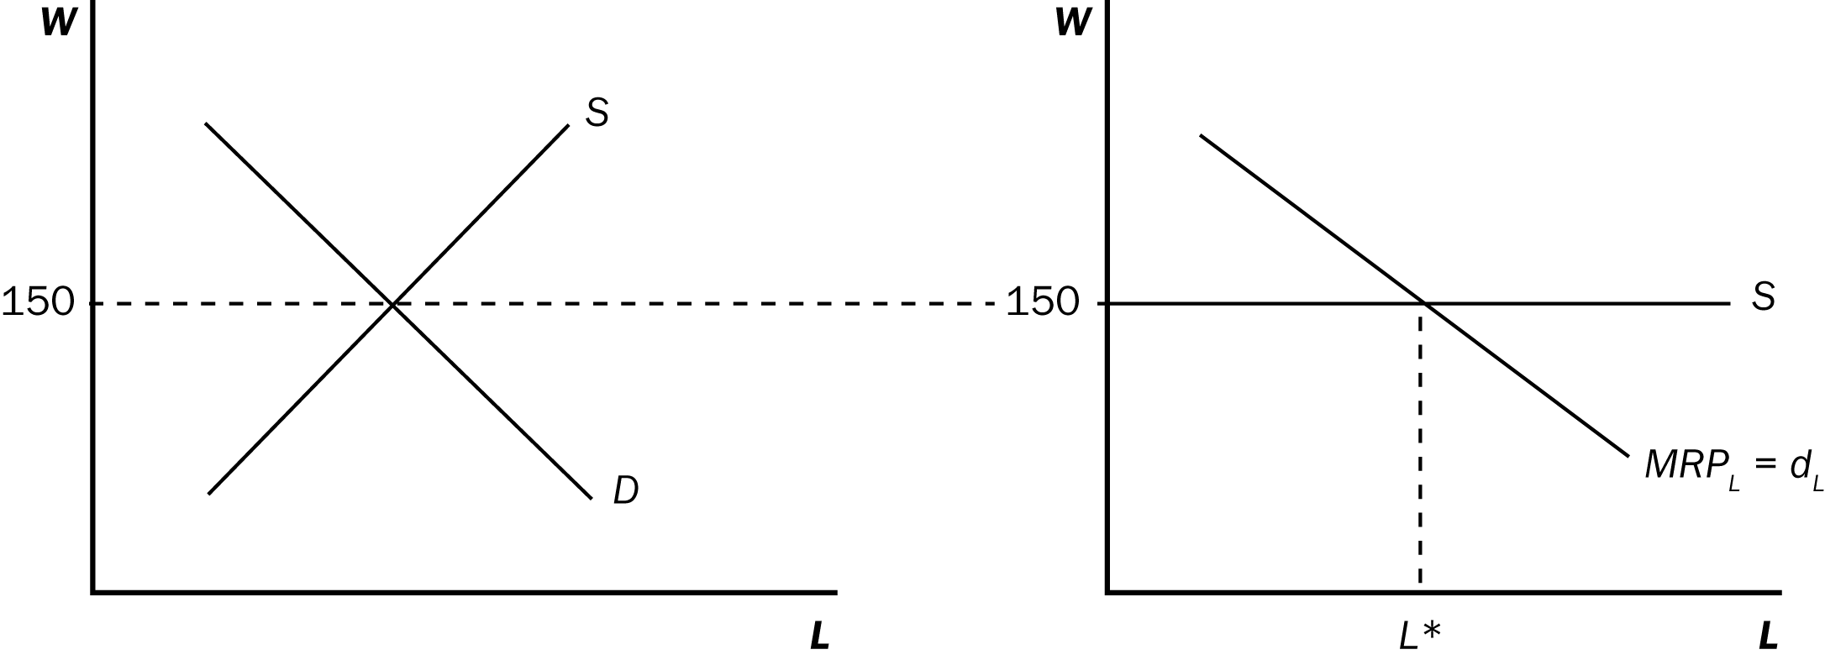

Figure 8

d. The decrease in the supply of labor will raise the equilibrium wage (see Figure 9). The increase in wage will reduce the profit-maximizing level of labor hired in both the pencil market and by Leadbelly. The value of the marginal product of workers will rise to the level of the new wage. Because the price of pencils has not changed and the value of the marginal product increases, the marginal product of labor must increase. This change in the marginal product of labor is consistent with diminishing marginal product and a lower level of labor.

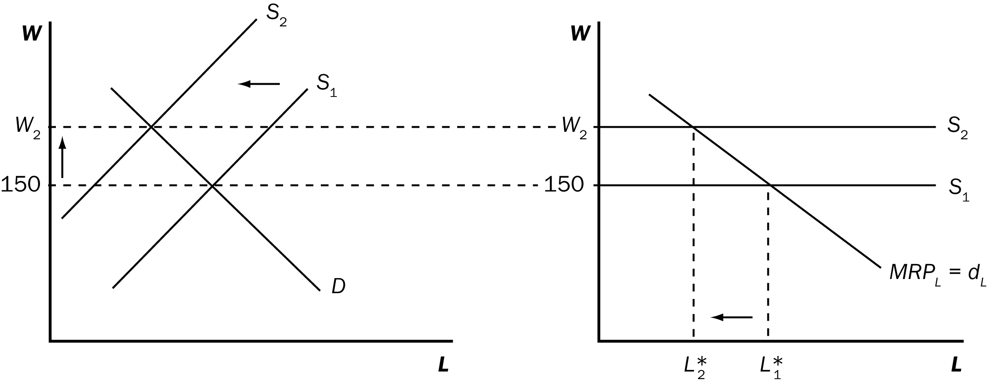

Figure 9

8. a. Figure 10 shows the U.S. capital market when there is an inflow of capital from abroad. The inflow of capital shifts the supply curve to the right, from S₁ to S₂. The result is a reduction in the rental price of capital from r₁ to r₂ and an increase in the quantity of capital from K₁ to K₂.

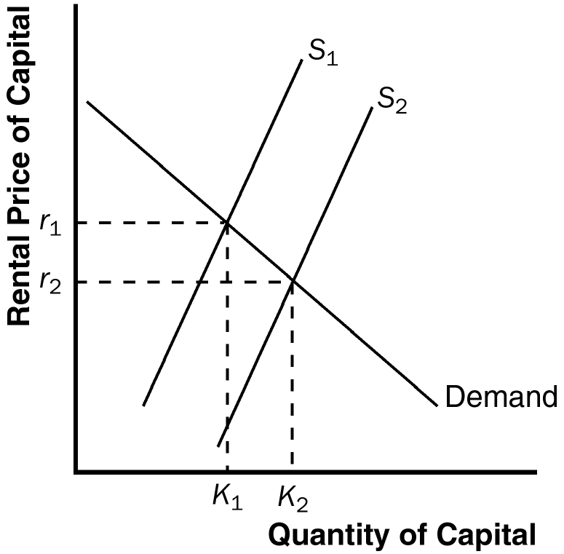

Figure 10

b. The increase in capital increases the marginal product of labor and the value of the marginal product of labor for any given quantity of labor. Figure 11 shows this as a shift in the demand for labor from D₁ to D₂. As a result, the wage rate rises from w₁ to w₂ and the quantity of labor rises from L₁ to L₂.

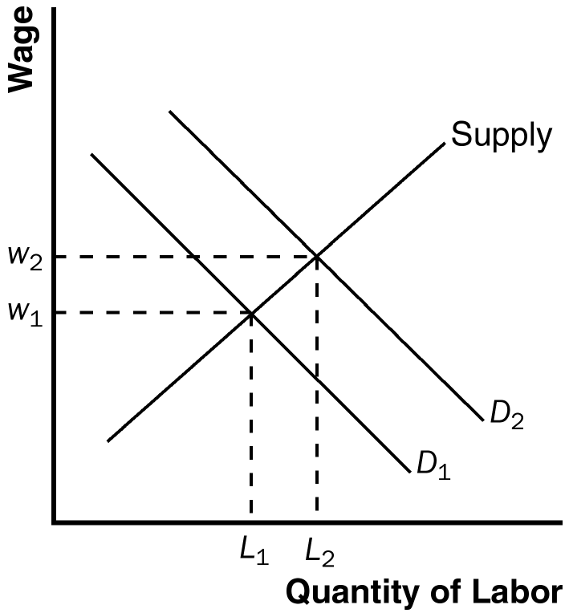

Figure 11

9. a. If a firm already gives workers fringe benefits valued at more than $3, the new law would have no effect. But a firm that currently has fringe benefits less than $3 would be affected by the law. Imagine a firm that currently pays no fringe benefits at all. The requirement that it pay fringe benefits of $3 reduces the value of the marginal product of labor effectively by $3 in terms of the cash wage the firm is willing to pay. This is shown in Figure 12 as a leftward shift in the firm's demand for labor from D₁ to D₂, a shift of exactly $3.

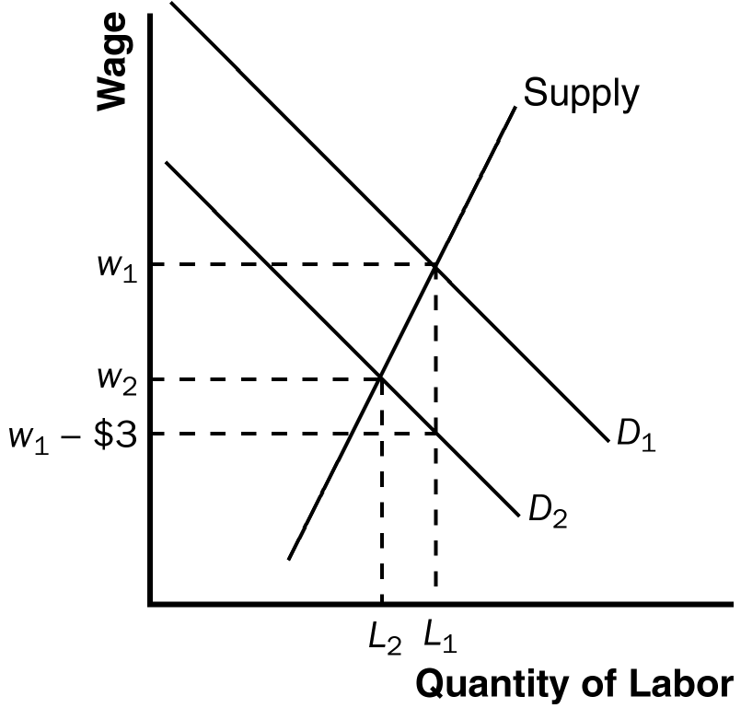

Figure 12

b. Because the supply curve has a positive but finite slope, the new equilibrium will be one in which the new wage, w₂, is less than the old wage, w₁, but w₂ > w₁ − $3. The quantity of labor also declines.

c. The preceding analysis is incomplete, of course, because it ignores the fact that the fringe benefits are valuable to workers. As a result, the supply curve of labor might increase, shown as a shift to the right in the supply of labor in Figure 13. In general, workers would prefer cash to specific benefits, so the mandated fringe benefits are not worth as much as cash would be. But in the case of fringe benefits there are two offsetting advantages: (1) fringe benefits are not taxed; and (2) firms offer cheaper provision of health care than workers could purchase on their own. Thus, whether the fringe benefits are worth more or less than $3 depends on which of these effects dominates.
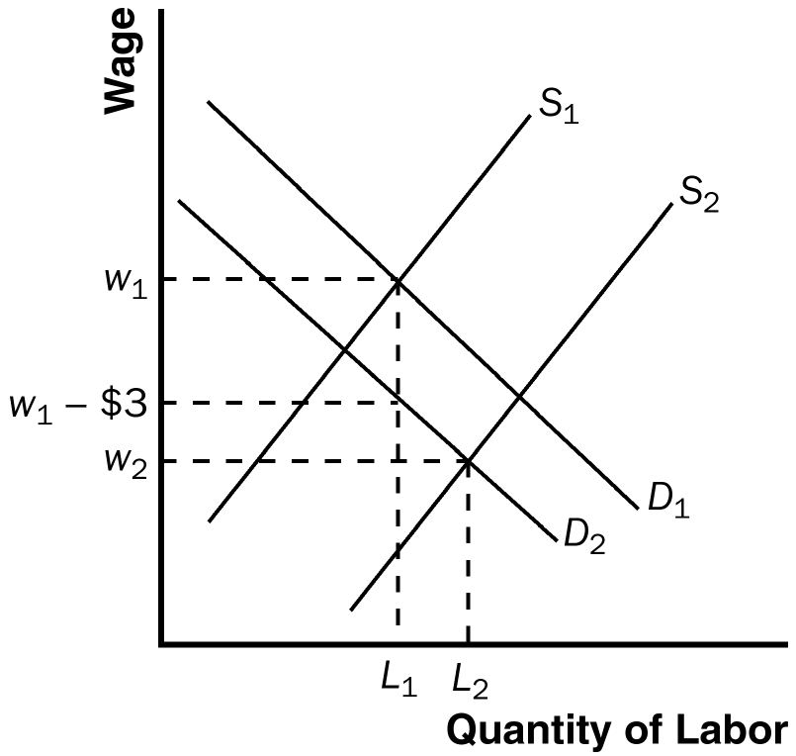

Figure 13

Figure 13 is drawn under the assumption that the fringe benefits are worth more than $3 to the workers. In this case, the new wage, w₂, is less than w₁ – $3 and the quantity of labor increases from L₁ to L₂.
If the shift in the supply curve were the same as the shift in the demand curve, then w₂ = w₁ – $3 and the quantity of labor remains unchanged.
If the shift in the supply curve were less than the shift in the demand curve, then w₂ > w₁ – $3 and the quantity of labor decreases.
In all three cases, there is a lower wage and higher quantity of labor than if the supply curve were unchanged.
d. Because a minimum-wage law would not allow the wage to decline when greater fringe benefits are mandated, it would lead to increased unemployment, because firms would refuse to pay workers more than the value of their marginal product.

